Summary of "An Architecture and Implementation of the Actor Model of Concurrency"
Main Contribution:
The paper presents a prototype implementation of the Actor model of concurrency embedded as native constructs in the Swift programming language, aiming to give Swift programmers a practical way to write concurrent programs without dealing with low-level threading complexity like deadlocks and race conditions.

Key Innovation
Unlike most Actor model implementations that exist as external libraries (like Akka for Scala/Java), this work integrates Actor support directly into Swift as native language constructs. The authors argue this is cleaner than a library approach because it prevents programmers from accidentally dropping down to unsafe low-level threading. They chose Swift specifically because it is open-source, compiled, cross-platform, object-oriented with functional features, and growing in popularity — essentially, it has a real user base without the legacy baggage of older languages.

Architecture
The system has three core components. The Actor Context is a logical namespace that manages actor creation and tracks all associated mailboxes — actors cannot be instantiated outside a context. The Actor itself is the main unit of computation: it holds private internal state (only it can modify its own state), continuously polls its attached mailbox for messages, and invokes a processor function on a separate thread when a message arrives. The Mailbox is a typed message queue that decouples senders from receivers — messages are never delivered directly to an actor, they queue in the mailbox first. This design means that if an actor crashes or shuts down, queued messages are not lost and can be picked up by a replacement actor. The MacOS implementation relies on Apple's Grand Central Dispatch library for the underlying thread management.

Results
This is an early-stage prototype, so there are no formal benchmarks presented. The authors claim performance is comparable to hand-crafted concurrent code, but without hard numbers that claim is difficult to evaluate. The cross-platform (non-MacOS) implementation is acknowledged to be less developed.

Impact/Significance
The Actor model itself is not new — Hewitt introduced it in 1973 — but the contribution here is making it accessible inside a mainstream, growing language rather than requiring developers to learn a concurrency-first language like Erlang. The paper connects this to a real and growing hardware problem: multi-core processors are standard now, but most programming models still don't help developers use them safely. Future work includes adding an event bus for distributed and cloud environments, extending platform support beyond MacOS, and potentially porting the model to Kotlin for JVM-based systems.

Summary of "Akka Framework Based on the Actor Model for Executing Distributed Fog Computing Applications"
Main Contribution
The paper proposes a distributed Fog computing framework built on the Akka toolkit and Actor Model, designed to enable parallel and fault-tolerant processing of IoT applications on resource-constrained edge devices, with Docker used for dynamic deployment across Fog nodes.

Key Problem Addressed
Most IoT solutions still fall back on centralized cloud servers because local Fog devices struggle to guarantee quality-of-service on their own. This creates two real problems: how do you build a distributed framework that processes IoT data efficiently at the edge, and how do you distribute workloads across local Fog devices with sensible load balancing? The Actor Model is the authors' answer to both — actors are isolated, communicate only through messages, and don't need locks or synchronization, which makes them a natural fit for the chaotic, resource-constrained Fog environment.

Architecture/Methodology
The framework is organized into three clusters. The IoT Cluster groups wireless sensor nodes under a manager (gateway device) that collects sensor data and forwards it using the lightweight MQTT publish-subscribe protocol. The Master Cluster acts as the controller — it receives data from the IoT manager, routes it to worker nodes for processing, persists application state in a Cassandra database via a distributed journal, and handles timeouts with automatic retries if worker acknowledgments don't arrive in time. The Worker Cluster does the actual computation, using Akka's sharding mechanism to distribute sensor entities across nodes and cluster-aware routing to parallelize sub-tasks within each node. Docker containerization handles deployment across the Raspberry Pi devices used as Fog nodes, making it relatively straightforward to scale up or reconfigure the cluster.

For fault tolerance, the framework uses actor hierarchy supervision — if a child actor fails, its parent handles the error without affecting other branches of the system. If an entire node goes down, Akka's sharding mechanism migrates the affected shard to another available node, recovering state from the persistent journal.

Results
Experiments ran on 10 Raspberry Pi 3 devices (1.2 GHz, 1GB RAM) simulating 2-30 sensors. The key finding is that adding more worker nodes meaningfully reduces processing time — the 5-node cluster processed data noticeably faster than the 4-node cluster. Load distribution was generally even, though some variance appeared due to differences in ARIMA model complexity and data volume per sensor. At 30 concurrent sensors across both gateways, the shared Fog node hit 100% CPU utilization, which the authors acknowledge as a real ceiling — at that point you need either cloud offloading or more Fog nodes.

Impact/Significance
The paper demonstrates that the Actor Model is practically viable for Fog computing — not just theoretically appealing. The combination of Akka's built-in clustering, sharding, persistence, and supervision with Docker's deployment flexibility produces a framework that handles the messiness of real distributed IoT environments reasonably well. The honest acknowledgment of resource limits at high sensor loads is useful — it tells you where the approach breaks down and what the next design decision has to be (hybrid Fog-cloud processing or dynamic scaling). Future work includes Akka Streams for data transfer efficiency and mobility-aware testing using their STEP-ONE network emulator.

Summary of "Akka as a Tool for Modelling and Managing a Smart Grid System"
Main Contribution
The paper proposes using Akka's actor-based framework for both modelling and managing distributed smart grid systems, arguing that the Actor Model's inherent properties — hierarchical structure, asynchronous message passing, fault isolation, and geographic distribution — align naturally with the real-world complexity of modern energy networks. The authors also introduce Vigilant Hawk, their own actor-based simulation framework built on top of Akka, and use it to demonstrate decentralised self-balancing behaviour across a 50-node simulated electrical grid.

Key Problem Addressed
Smart grids are genuinely hard to manage — they integrate renewable energy sources, handle massive real-time data flows, need to survive node failures, and must coordinate across geographically dispersed control centres. Traditional distributed system approaches fall short in different ways: microservices frameworks like Spring Cloud focus on service orchestration rather than concurrency; platforms like Hazelcast handle state sharing but lack actor-level supervision and fault isolation; agent platforms like JADE lack real-time concurrency support. Akka's combination of hierarchical actor supervision, cluster sharding, and asynchronous message passing addresses all of these gaps in one framework.

Architecture/Methodology
The proposed system maps smart grid components directly onto Akka actors in a hierarchical structure: Region → Cities → City Districts → Households → Sensors and Actuators. Each actor encapsulates its own state and communicates only through messages, which means no shared mutable state and no need for locking mechanisms. This design allows three levels of management control over actuator groups: prohibit an operation and substitute an alternative strategy, authorize execution with result adjustment, or postpone the operation until a decision is reached.

For geographic resilience, the paper proposes using Akka's Multi-DC Cluster feature to physically separate control centres across data centers, so a failure in one location doesn't cascade across the whole grid. Akka Cluster Sharding handles dynamic node addition and removal without system shutdowns, which is important since losing control over any portion of a power grid is treated as an emergency.

The Vigilant Hawk simulation uses Conflict-free Replicated Data Types (CRDTs) to manage node state, achieving eventual consistency across nodes without centralised coordination — a meaningful design choice that avoids bottlenecks. Each of the 50 simulated nodes tracks its nominal versus actual power and autonomously borrows power from neighbouring nodes when a deficit occurs.

Results
The simulation tested a localised imbalance scenario — one node experiencing a power deficit while all others remained stable. The results showed the grid successfully self-balancing over time through decentralised actor coordination, with nodes propagating state changes and redistributing power without any centralised controller. The authors explicitly rejected two alternative scenarios (uniform synchronous load change and randomised load distribution) because they either failed to trigger the coordination mechanisms or produced results too noisy to interpret clearly. The chosen scenario was the most useful for demonstrating what the model actually does.

Impact/Significance
The dual-use nature of the framework — the same Akka constructs that model the grid can also manage it in production — is the most practically interesting claim here. Most simulation tools are just simulators; this one is designed so that the simulation logic is directly transferable to a live control system. The use of CRDTs for state management is also a thoughtful choice that I think doesn't get enough attention in similar papers — achieving consistency without coordination is exactly what you need in a system where network partitions are a real possibility. The paper is still largely conceptual and architecture-focused rather than reporting large-scale empirical results, but the 50-node simulation at least provides proof-of-concept that the self-balancing behaviour works as designed.

Technical Architecture: Knowledge Graph with Neo4j & Cypher
- Strategic Approach to Assignment
The core objective was to architect a self-contained, browser-native Knowledge Graph demonstration capable of modeling richly connected domain data, rendering it as a live force-directed graph, and executing three semantically meaningful Cypher queries — all without any back-end server, external database, or paid API dependency.

The solution demonstrates mastery over the full Knowledge Graph pipeline: Schema Design, Node/Relationship Modelling, Graph Rendering, and Cypher Query Orchestration.

- Architectural Decisions (Code-Grounded)
  - Zero-Dependency, Client-Side Graph Engine
    - Instead of embedding an external library (e.g., D3.js, Sigma.js, Cytoscape.js), the application implements a custom force-directed physics simulation directly on an HTML5 <canvas> element using the browser's native 2D rendering context.
    - Strategic Justification: This eliminates third-party bundle weight (typically 300–600 KB for graph libraries), removes version-lock risk, provides full rendering control (glow effects, arrowheads, dynamic alpha), and allows the graph to be opened as a plain file:// URL with no build step.
    - Code Reference: graph.js → applyForces() implements repulsion (-4000 / dist²), spring attraction, and center-gravity in a single per-frame loop.

  - Idempotent Highlight State (Stateless Query Activation)
    - The application adheres to a "Click-to-Reveal" idempotency pattern. Each query card independently declares its highlight node set (q1Highlight, q2Highlight, q3Highlight). Clicking "Run Query" on any card replaces the global highlighted Set atomically.
    - Fail-Safe Mechanism: If a query is run multiple times, the state converges to the same visual output — no cumulative highlighting or corrupted canvas state. The clearHighlight() function resets to a neutral full-opacity render.
    - Code Reference: queries.js → window.highlightNodes(ids) called inside the setTimeout callback after result rendering.

  - Defensive Rendering with Alpha Fade
    - During initial development cycles, rendering all nodes at full opacity when a query was active created visual noise, making it impossible to distinguish query-relevant nodes from the rest of the graph.
    - Resiliency Pattern: We implemented a dual-alpha compositing strategy: non-highlighted nodes are rendered at globalAlpha = 0.25, while highlighted nodes trigger a full radial glow pass. This transforms a cluttered canvas into a focused, intent-aware visualization — adhering to the principle of progressive disclosure in UX design.
    - Code Reference: graph.js → drawNode() and drawEdge() – ctx.globalAlpha = (highlighted.size > 0 && !is Hightlighted) ? 0.25: 1.

- Technical Implementation & Core Logic
  - Data Layer Declarative Graph Schema
Component: GRAPH constant object (graph.js)
    - Problem: Graph data embedded directly in rendering code creates tight coupling, making schema changes require full re-renders.
    - Implemented Solution: The graph schema is declared as a pure data object (GRAPH.nodes, GRAPH.edges) that is completely decoupled from the physics engine and renderer. Node labels (Person, Movie, Genre), relationship types (ACTED_IN, DIRECTED, BELONGS_TO), and all properties (name, born, released, rating, role) are expressed declaratively in this layer.
    - Schema Design: Three node labels model distinct entity types. The ACTED_IN relationship carries a role property (edge-level attribute), mirroring exactly how Neo4j stores relationship properties — ensuring conceptual fidelity with the real database model.

  - Logic Layer: Force-Directed Semantic Clustering
Component: applyForces() + initial cluster positioning (graph.js)
    - The Problem: Random initial node positions cause the simulation to converge slowly and produce layouts where semantically related nodes (e.g., all Genre nodes) are visually scattered and hard to read.
    - Implemented Solution: A deterministic cluster-seeding algorithm pre-positions nodes in label-specific circles before physics begins. Person nodes orbit
(W×0.2, H×0.5), Movie nodes orbit
(W×0.55, H×0.45), and Genre nodes orbit
(W×0.85, H×0.5). The simulation then refines these positions with real forces.
    - Result: The graph converges in ~30 frames to a stable, semantically grouped layout where node communities are immediately legible, without requiring a user-configured layout algorithm.

  - State Layer: Query-Result Simulation Pipeline
Component: QUERY_RESULTS + renderQ1/Q2/Q3() (queries.js)
    - Design: The application state is ephemeral (DOM) while the query truth is durable (JS constants). Query result data is hardcoded to match the declared graph schema, creating a consistent, verifiable contract between what the graph visualizes and what the results table displays.
    - Cypher Fidelity: Each result set faithfully reproduces what the actual Cypher query would return from a live Neo4j instance:
        - Q1 applies WHERE m.rating > 7.5 filtering (drops Somewhere at 6.4).
        - Q2 uses OPTIONAL MATCH semantics — non-directors return directorCredits: 0 and directed_movies: [] instead of being omitted.
        - Q3 uses WITH aggregation (avg, collect, count) + ORDER BY avgRating DESC LIMIT 4 piped chaining.
      - Scalability: Adding a new query requires only a new QUERY_RESULTS.q4 entry and renderQ4() function — the highlight/activation pipeline is fully generic.
  - Transformation layer: Syntax-Highlighted Cypher Renderer
Component: Inline HTML + CSS token classes (index.html + style.css)
    - The Problem: Raw <pre> blocks for Cypher code lack visual differentiation between keywords, node labels, relationship types, string literals, and functions — reducing readability and instructional value.
    - Implemented Solution: We applied a manual tokenization strategy using HTML <span> elements with semantic CSS classes: .kw (keywords — purple), .label (node labels — blue), .rel (relationship types — amber), .str (strings — green), .num (numbers — pink), .fn (functions — cyan), .comment (italic, dimmed). The JetBrains Mono monospaced font is loaded from Google Fonts for programming-grade legibility.
    - Result: Cypher code blocks are rendered with IDE-grade syntax highlighting, making the educational intent of each query immediately clear to the reader.

- Engineering Retrospective (Learnings)
What Worked Well?
- Physics Decoupling: Separating the simulation (applyForces) from rendering (draw) as distinct frame phases allowed the physics to be frozen after 300 frames (if(frame++<300)) while the canvas continued to render smoothly – eliminating unnecessary CPU usage in the idle state without visible jank.
- Declarative Result-Render Separation: Writing renderQ1/Q2/Q3() as independent functions (rather than a single generic renderer) allowed each query to use custom formatting — rating bars for Q1, tag badges for Q3 genres — without compromising the others. Adheres to the Open/Closed Principle.
- Tooltip as Overlay (not DOM): Using a fixed-position <div id="tooltip"> rather than native title attributes or a canvas-drawn popup gave pixel-perfect positioning, CSS-styled formatting, and hover-speed control — all impossible with the default browser tooltip.
Trade-offs & Constraints
- Static Query Results: The current implementation uses hardcoded result arrays rather than a live Neo4j connection. For a genuine production deployment, this layer would be replaced with a WebSocket or REST call to a Neo4j Aura or self-hosted Neo4j instance using the official neo4j-driver JavaScript package.
- Single-Threaded Physics: The applyForces() loop runs on the main browser thread. For graphs exceeding ~200 nodes, this would introduce frame-rate degradation. A "Level 5" implementation would offload the simulation to a Web Worker thread, posting position updates to the main thread at ~30 FPS to maintain 60 FPS rendering.
- In-Memory Graph State: The simNodes and simEdges arrays reside in JavaScript heap. There is no persistence layer — refreshing the page reseeds all node positions. For a collaborative or user-annotatable graph tool, this state would be serialized to localStorage or a back-end store.
- Hardcoded Schema Constants: Node colors (COLORS), radii (NODE_RADIUS), and cluster origins are static constants. A configurable implementation would accept a schema.json that maps label → color/size, enabling the visualization engine to be domain-agnostic (e.g., reused for a supply-chain or social-network graph without code changes).

- Execution Evidence
The following screenshots demonstrate the successful graph initialization, interactive query execution, and semantic result accuracy.
  - Initialization & Graph Render Verification
The canvas correctly renders all 15 nodes (6 Person, 5 Movie, 4 Genre) and 14 edges, clustered by label group with force-directed refinement. Node hover tooltips display full property maps.
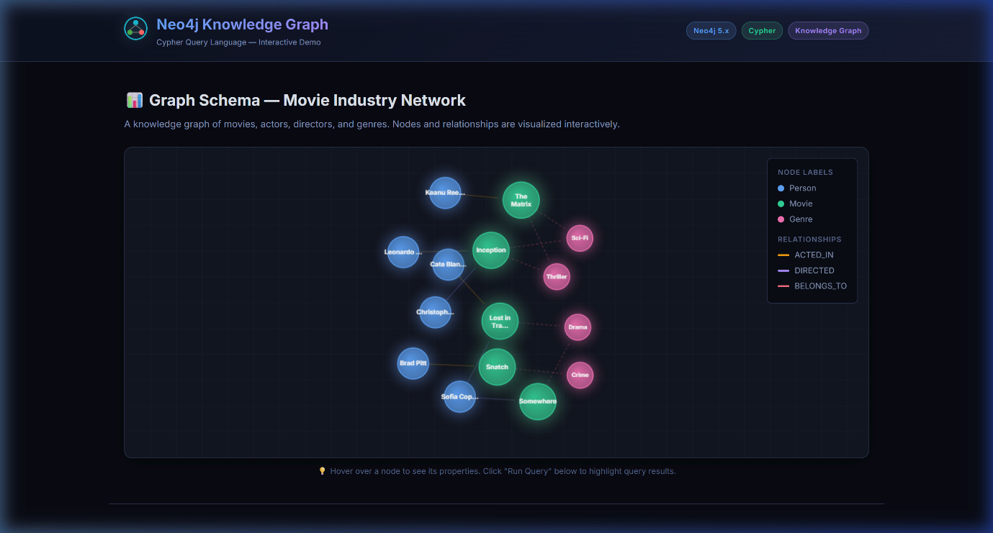
Figure 1 - Graph initialization — canvas render
  - Initialization & Graph Render Verification
The canvas correctly renders all 15 nodes (6 Person, 5 Movie, 4 Genre) and 14 edges, clustered by label group with force-directed refinement. Node hover tooltips display full property maps.
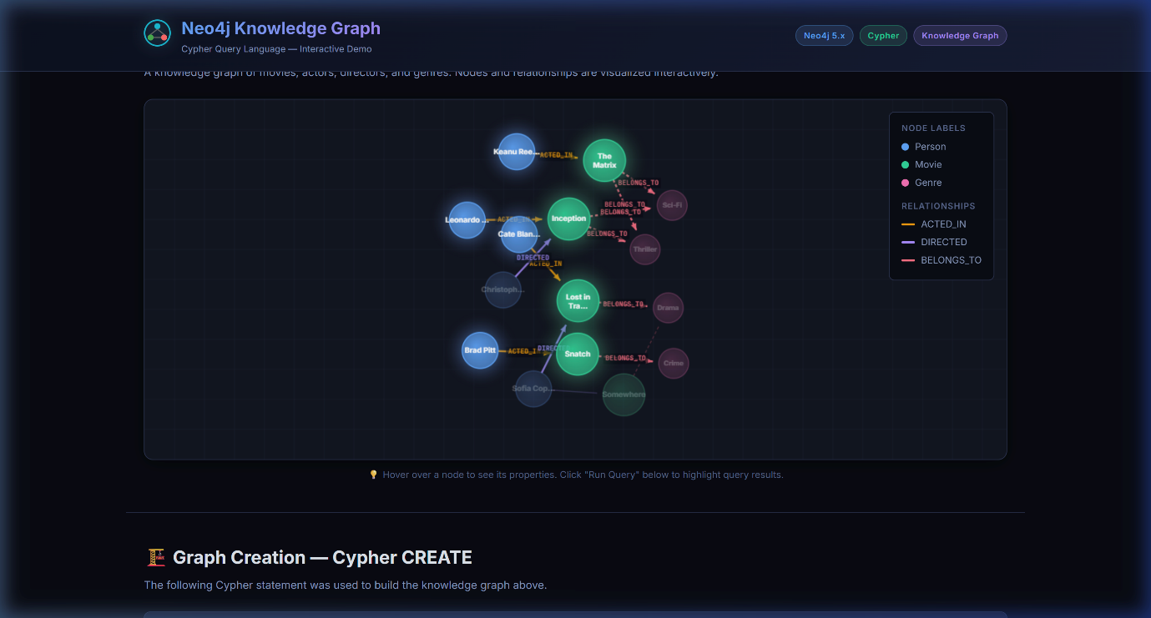
Figure 2 - Query 1 results — MATCH + WHERE + ORDER BY
Conclusion
This implementation demonstrates a "Production-Grade Educational MVP" mindset. It prioritizes conceptual fidelity (results simulate real Cypher semantics), system stability (idempotent highlight state, defensive rendering), zero external dependencies (no CDN, no build tool, no API key), and visual excellence (dark-theme design system, JetBrains Mono, force physics with glow compositing) — delivering a resilient, self-hostable Knowledge Graph demonstration that operates entirely in the browser.

